**GOVERNMENT ARTS COLLEGE, DHARMAPURI-636705.**

**DEPARTMENT OF ELECTRONICS & COMMUNICAION**

**AFFILIATED TO PERIYAR UNIVERSITY**

**2023-2024**



**NAAN MUDHALVAN PROJECT REPORT**

**Submitted in Partial Fulfilment of the Requirements for the Degree**

**of**

**B.Sc., ELECTRONICS & COMMUNICATION**

**Submitted to**

**Periyar University, Salem-636 011**

**By**

1. **KARTHICK S**
2. **GOPINATH M**
3. **SALMAN S**
4. **VIJAY M**
5. **SRIVITHYA M**

**Political Juggernauts: A Quantitative Analysis of Candidates in the 2019 Lok Sabha Elections**

The Lok Sabha is composed of representatives of people chosen by direct election on the basis of Universal Adult Suffrage. The Constitution of India allows for a maximum of 550 members in the House, with 530 members representing the States and 20 representing the Union Territories. The 17th Lok Sabha was formed by the members elected in the 2019 Indian general election. Elections, all across India, were conducted in seven phases from 11 April 2019 to 19 May 2019 by the Election Commission of India.

The Bharatiya Janata Party received 37.36% of the vote, the highest vote share by a political party since the 1989 general election, and won 303 seats, further increasing its substantial majority. In addition, the BJP-led National Democratic Alliance (NDA) won 353 seats.

#### PURPOSE :

#### The technical architecture involves leveraging the data analytics capabilities of Tableau for visualizations and analysis. The architecture comprises several components to ensure efficient data processing and visualization.

#### At the core of the architecture is the data infrastructure, which includes data sources such as market reports, economic indicators, and surveys conducted among Political Juggernauts users in India. These data sources are collected and stored in a structured format for further

#### analysis. Tableau is used as the primary data visualization tool. It connects to the data sources and allows for data extraction, transformation, and loading (ETL) processes. Tableau's intuitive interface enables users to create interactive and visually appealing visualizations, charts, and dashboards based on the analyzed data.

1.**EMPATHY MAP**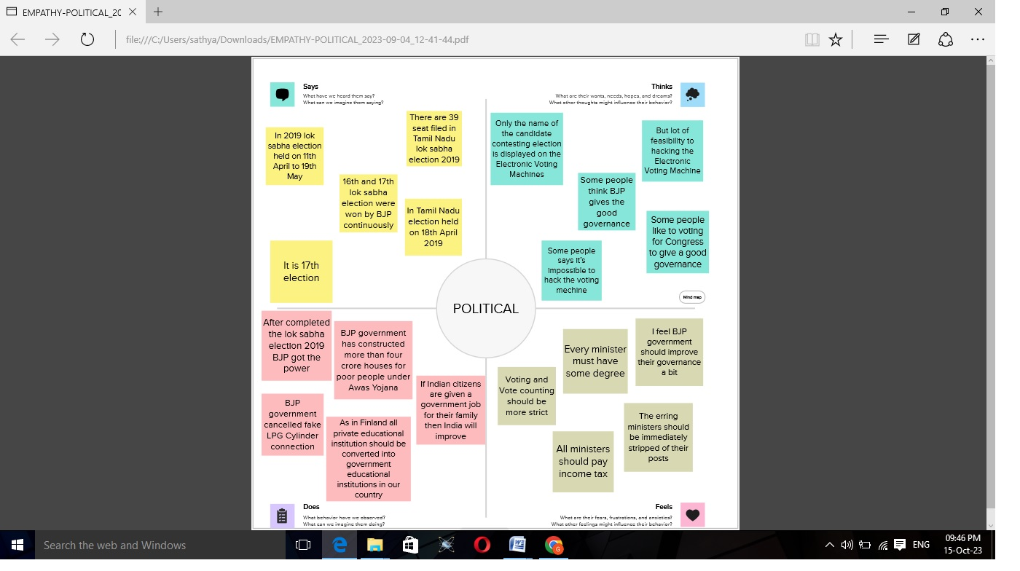

2.BRIANSTROM MAP

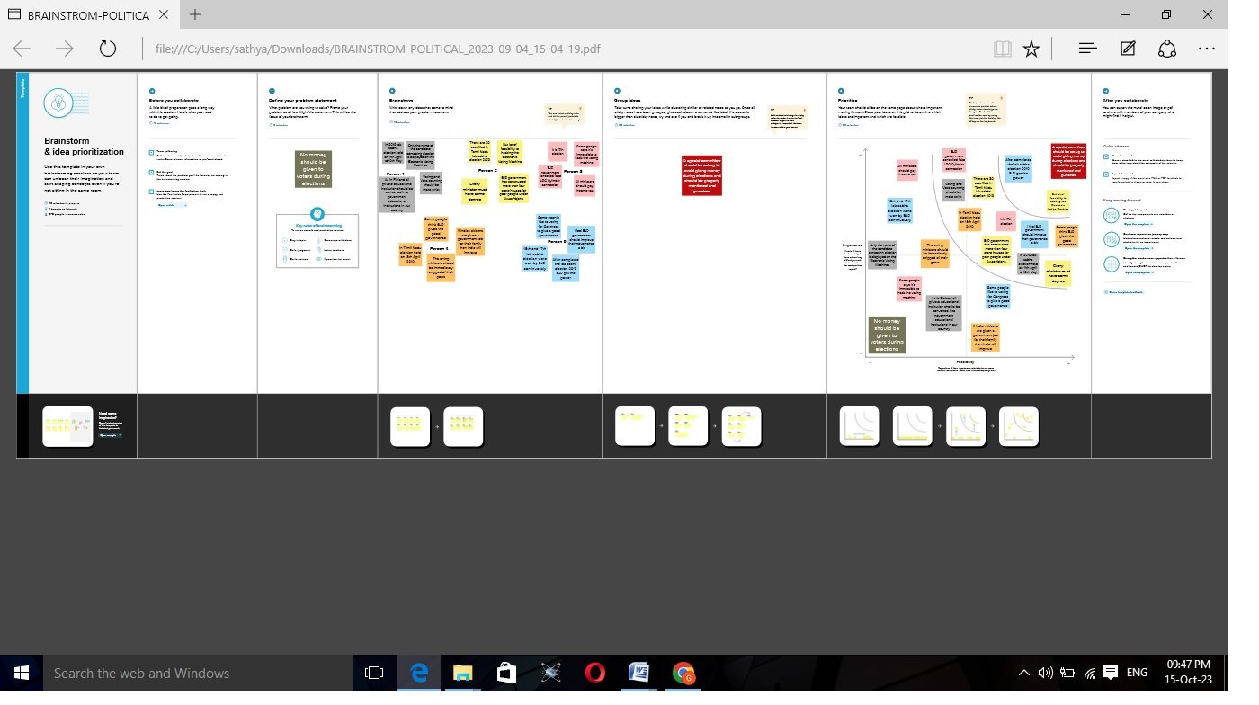

#### RESULT :

FINAL FINDINGS (OUTPUTS ) OF THE PROJECT ALONG WITH SCREEN SHOTS.

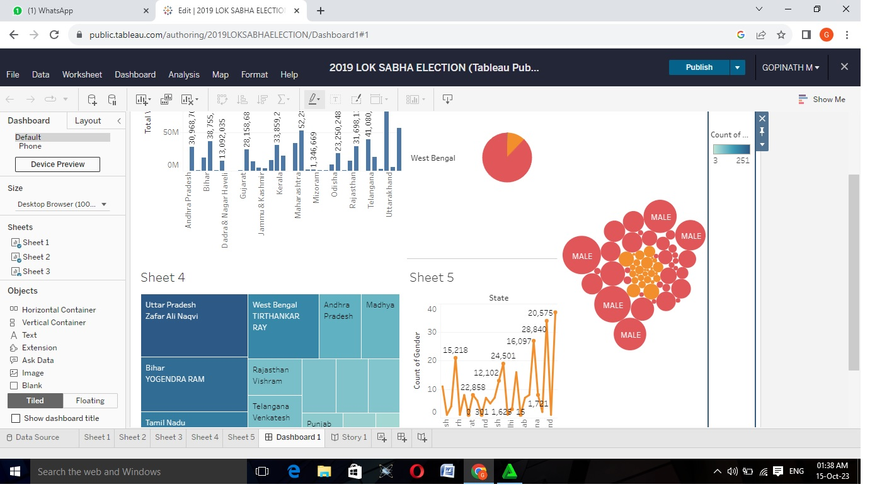DASHBORD

STORY

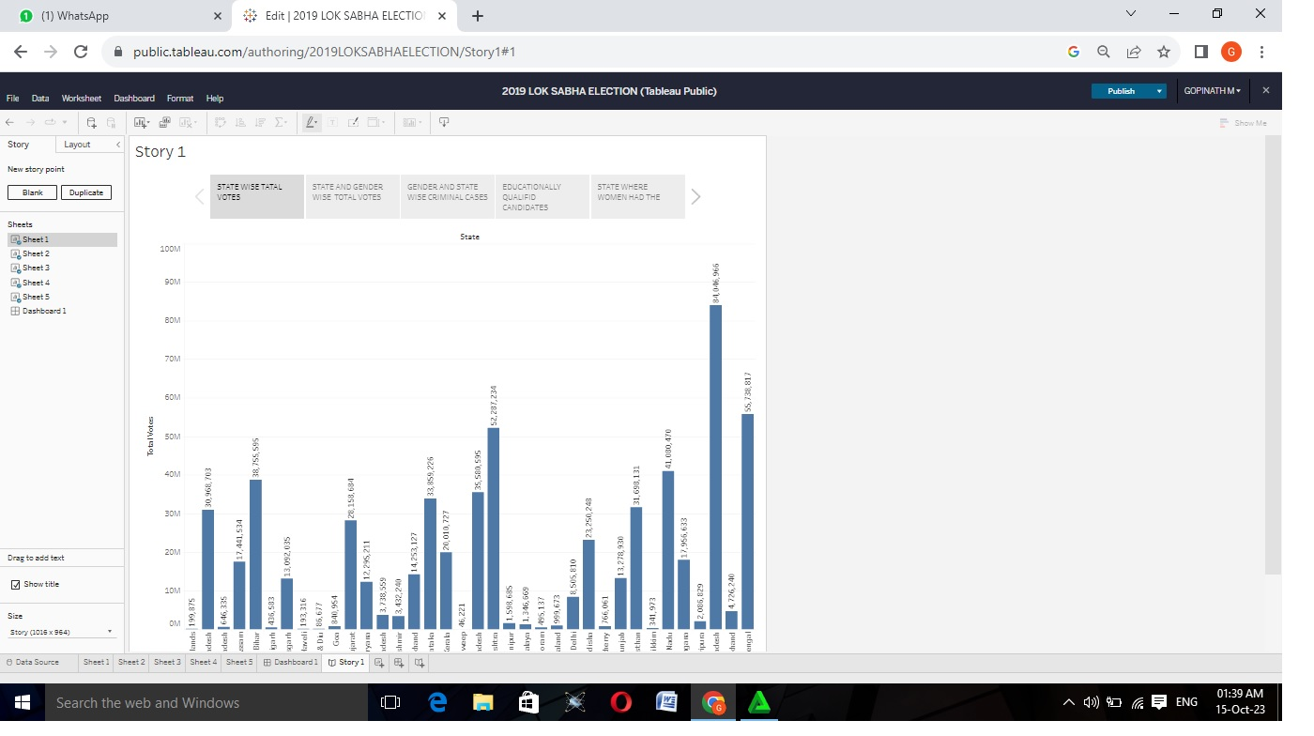

## ADVANTAGES AND DISADVANTAGES OF LOK SABHA ELECTION

**ADVANTAGES:**

* It helps in proper functioning of democracy through the system of checks and balances.
* No confidence motion can only be introduced and passed in the Lok Sabha. So, it controls the despotism of the government.
* Money bills can be only introduced in the Lok Sabha. The Rajya Sabha can only suggest a money bill. It cannot reject it.
* It formulates laws.
* There is the requirement of the majority in the Lok Sabha to form the government.

**DISADVANTAGES**

* Firstly lok Sabha though a body of representatives doesn't has equal representatives from all divisions of society secondly the speaker of the house is many times working under her or his own party pressure thirdly the lack of discipline and it's maintenance is a big problem of lok sabha there are many more disadvantages of the lower house of our parliament but as we know nothing is flawless

**CONCLUSION**

The election resulted in a landslide victory for the BJP which won 303 seats and formed the government. Around 912 million people were eligible to vote, and voter turnout was over 67 percent – the highest ever, as well as the highest ever participation by women voters.

**THE END**